Business Requirement Document

Requirement ID ART_002
Title: B2C-Hotel Module
Prepared by: Saivisweswaran
Prepared for: Al Rostamani Travels
Date Submitted: 09-Jul-2020
Document Number: ART_002

Ver.# | Date | Author | Change Description
1 | 10Jul20 | Sai | Draft
2 | 18jul20 | Ajith | Review
3 | 19jul20 | Sai | Draft2
4 | 20Jul20 | Ajith | Review
5 | 20Jul20 | Sai | Final

Table of Contents

1. Introduction 3
1.1. Purpose 3
1.2. Intended Audience 3
1.3. Requirement Scope 3
2. Requirement Overview 3
2.1. Proposed System 3

Introduction

Purpose

Purpose of this document is to address the Hotel Module Functional requirements that needs to be available in the Al Rostamani Travels B2C Portal.
.

Intended Audience
The main intended audience for this document are the business owners of the Al Rostamani Travels and CTS Team.

Requirement Scope

- Login Process:
  - The user shall be able to purchase a hotel as Registered logged in user or as a guest user.
- Hotel Search:
  - The below is the hotel search wizard that shall be available in the B2C portal. Refer Fig 1.
  - The user enters the search criteria and clicks on the search button. The system shall send requests to the suppliers.
  - Search Loading Mechanism: Once the user searches, an intermediate search loading page shall be viewed with the searched data until the results are displayed. This page can be used for advertising as well. Once the system receives the response from the supplier, the system shall show all the hotel results together (Max 15 seconds).

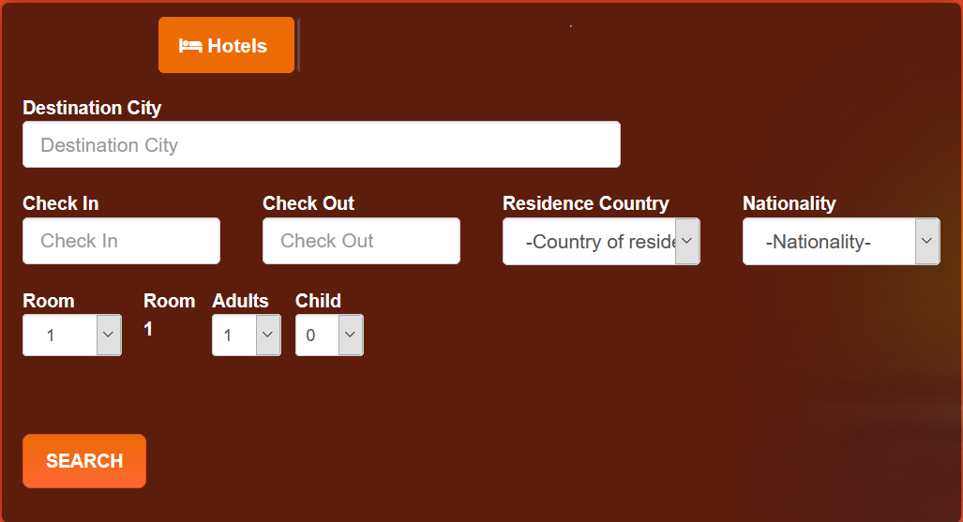
Fig 1: Search Frame

Following are the Attributes and business rules to create the screens.
Field type: Drop-Down(DD), Check Box(CB), Multi-select(MS), Text Box(TB), Mandatory(M), Conditional Mandatory(CM), Optional(O), Alpha characters(A), Numeric(N), Special Characters(S)

Field Name | Description | Field Type  M/O  A/N/S  Field width | Business Rules
Destination | Provision to select the cities | TB  M | In this text box, the user shall enter the city name. The field shall auto-populate the city name.
Check-in |  | Calendar filed  M | The user shall select the check-in date in this field
Check-Out |  | Calendar  M | The user shall select the check-out date in this field
Residence Country |  | DD  M | The system shall display the countries in this drop down list. The user shall select his/her country of residence.
Nationality |  | DD  M | The system shall display all the nationalities in this drop down list. The user shall select his/her nationality.
Room |  | DD  M | In this drop down list, the system shall display the number of rooms a user can select. The system shall display the values from 1 to 6. The user can select minimum of 1 room and to a maximum of 6 rooms. The system shall show the adult drop down list and child drop down list for each room count selected.
Adult |  | DD  M | In this drop down list the system display the values 1 to 4.
Child |  | DD  M | In this drop down list 0 to 2. If the user selects the value 1 or 2, the system child age drop down list. Ex: If 1 Child is selected, then system shall show 1 child age drop down list. If 2 child selected then 2 child age drop down fields will be shown.
Child Age |  | DD  M | Values from 1 to 11 will be listed. The user shall select the age of the child from this drop down list.

- Search Result:
  - The modify search screen shall be as per the search wizard mentioned in the Figure 1.
  - The result will be displayed based on lowest to highest. Refer Figure 2.
  - The hotels can be sorted out based on the following parameters
    - By Price (Lowest to highest or highest to lowest)
    - By Alphabetical order (Ascending to descending)

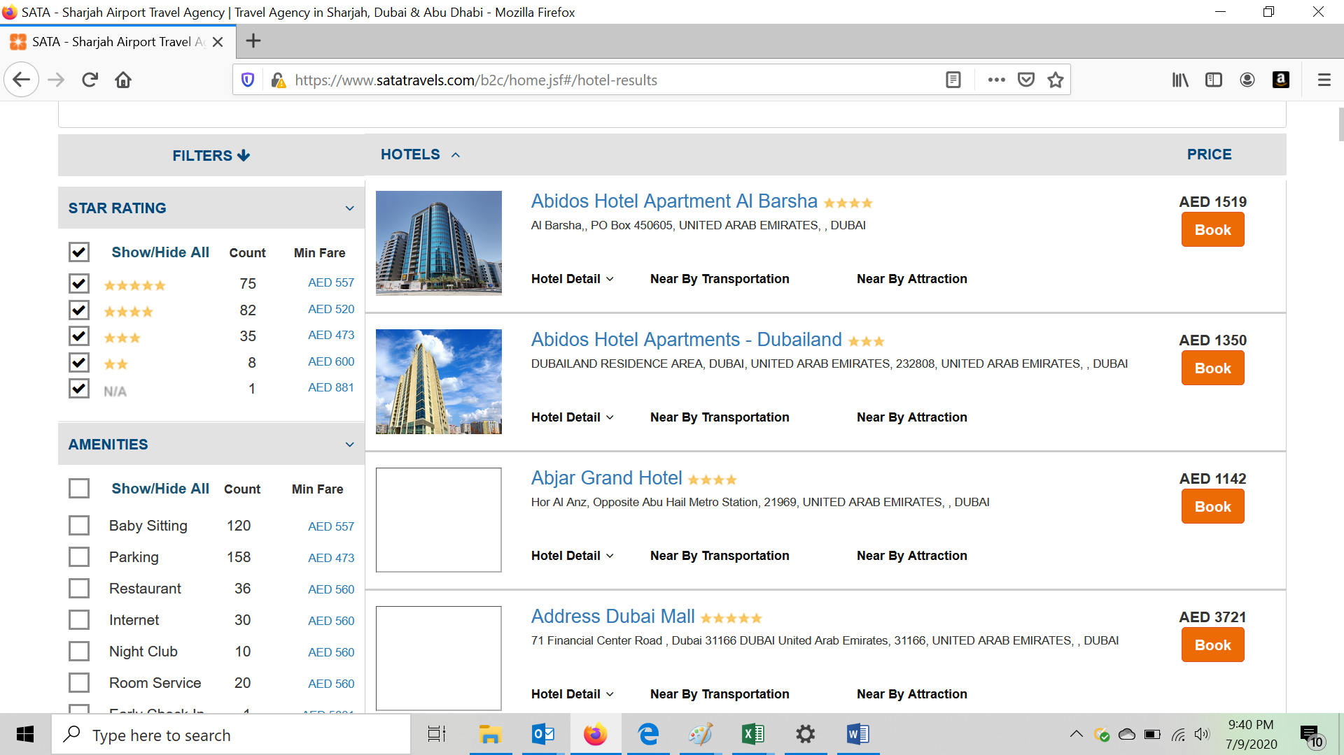
Fig 2: Hotel Search Result

  - The following filters shall be available (Filters shall be frozen when the user scrolls down to the page. This requirement is given for the flight module and the same shall be applied for the hotels.)
    - By Star Rating
    - By Amenities
    - By Price
    - By Hotel Name
    - By Property Name (Shall be brought only if all the Suppliers APIs provide this information)
    - By Area (Shall be brought only if all the Suppliers APIs provide this information)
  - Under the hotel details in the search result the following information shall be available. Refer Figure 3.
    - Gallery (by clicking the link, system shall show the images of the hotel)
    - Amenities info (by clicking the link, shows amenities of the hotel)
    - Nearby Attraction (by clicking the link shows the nearby places of the hotel)
    - Location (MAP) (by clicking the link shows the map of the hotel location)
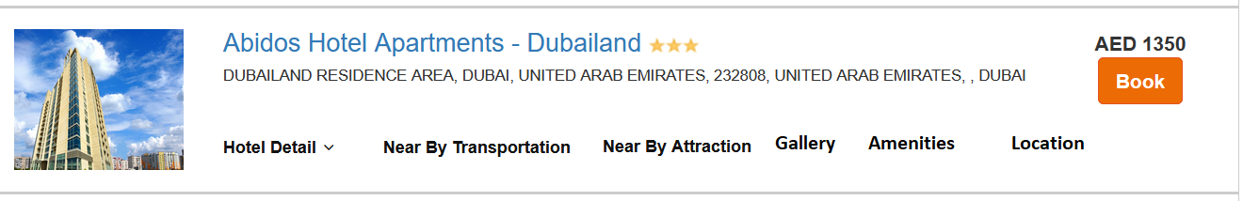
Fig 3: Hotel Details Additional Information

  - The user shall click the search button and gets redirected to the booking review screen.

- Booking Review Screen:
  - The system shall display the details of the hotel in the booking review screen. Refer the Fig 4 for the format.

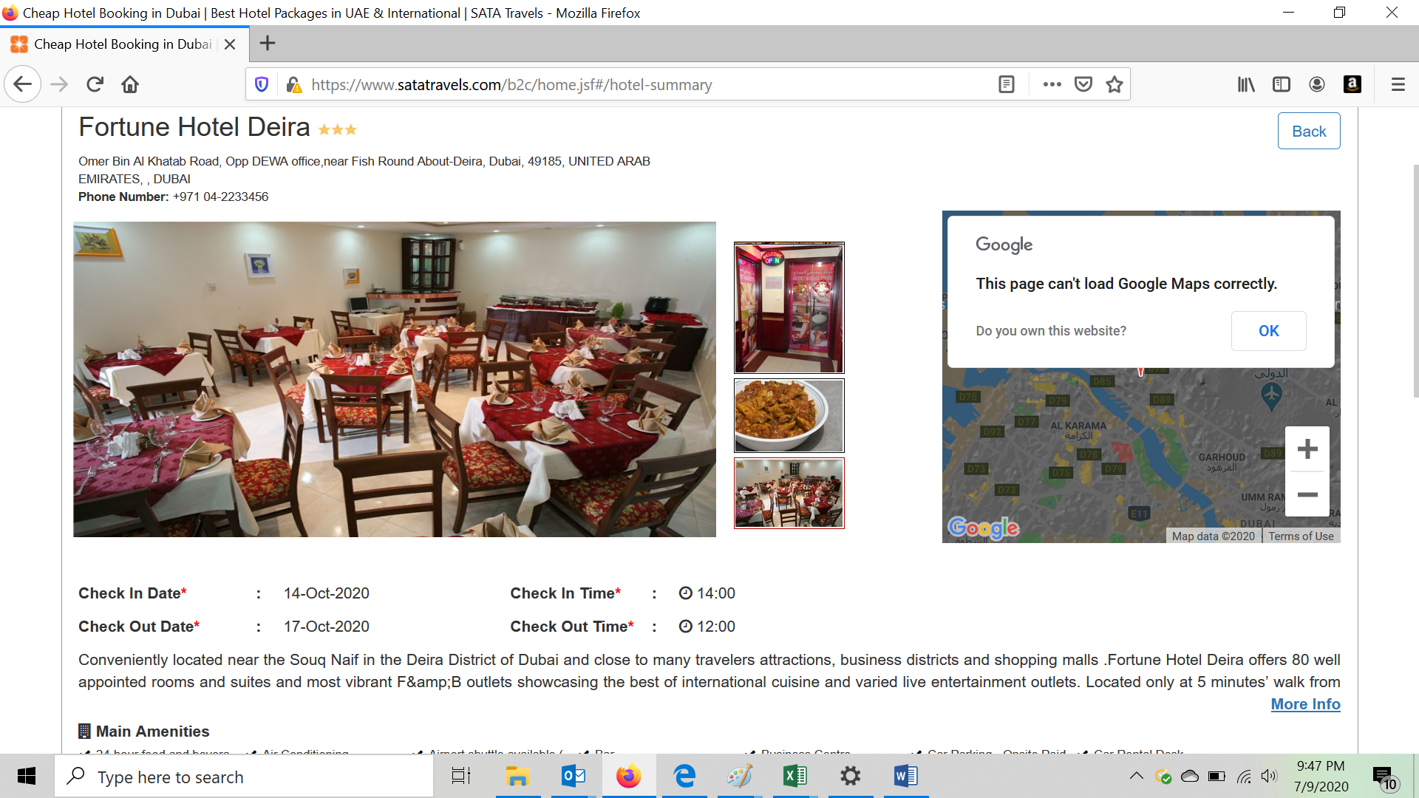
Fig 4: Booking Review Page
  - In the booking review page, the system shall all the rooms available. The room shall be listed with the following information. Refer Fig 5.
    - Cancellation policy (the cancellation policy pop up window will be having the supplier cancellation policy and the ART cancellation policy.)
    - Meal Type
    - Price

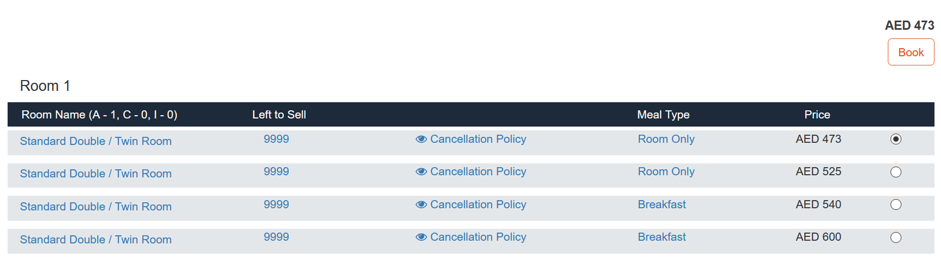
Fig 5: Room Selection

  - The user selects the room and clicks the book now button.
  - The user shall be redirected to the Itinerary details where the user can create/select the guest details and on the right side of the page, the fare details shall be shown. Refer Fig 6.
  - Special Services request: After selecting the room, the user shall have a provision to select the special services request (either the predefined list given by the supplier or if the text request input option if available from supplier needs to be considered).

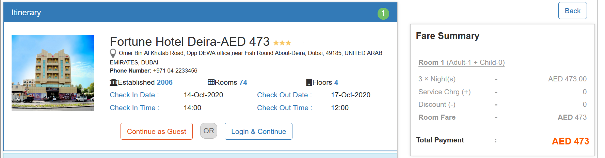
Fig 6: Itinerary Screen

- Booking Flow:
  - Guest User:
    - If the user has come as a guest user, then in the Itinerary screen the user shall have two options (Continue as Guest or Login & Continue).
    - The user shall click the button Continue as Guest.
    - The user shall enter their Email and clicks the Continue.
    - The user shall add the Guest details (Refer Figure 7) and checks the terms and conditions and the clicks the Proceed button to go to the payment gateway screen. Refer Fig 8
  - Logged In User (Login from the Home page).
    - In this case, the user shall login from the home page.
    - The user enters the search criteria and clicks on the search button. The system shall send requests to the suppliers.
    - The system shall show the results
    - The user shall select the hotel and in the hotel booking review screen selects the room type and then proceeds to the itinerary details.
    - The user shall be able to create a new guest or if the user wants to add his/her details then the user shall select the option “Use my profile”.
    - Or if the user wants to book for his/her dependencies then the user shall select from my traveller profiles. The system shall show the dependencies profiles and the user shall add the guest to the booking.
    - The user shall add the Guest details and checks the terms and conditions and the clicks the Proceed button to go to the payment gateway screen.

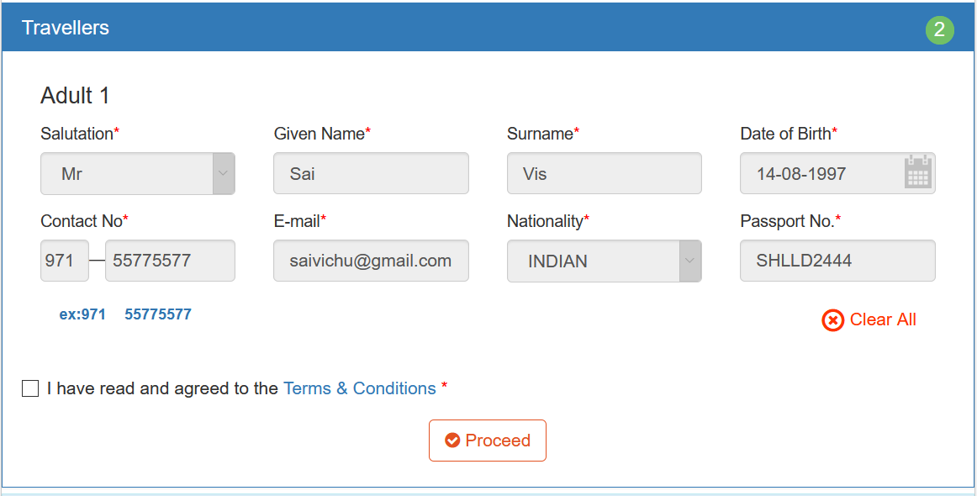
Fig 8: Guest Details Screen

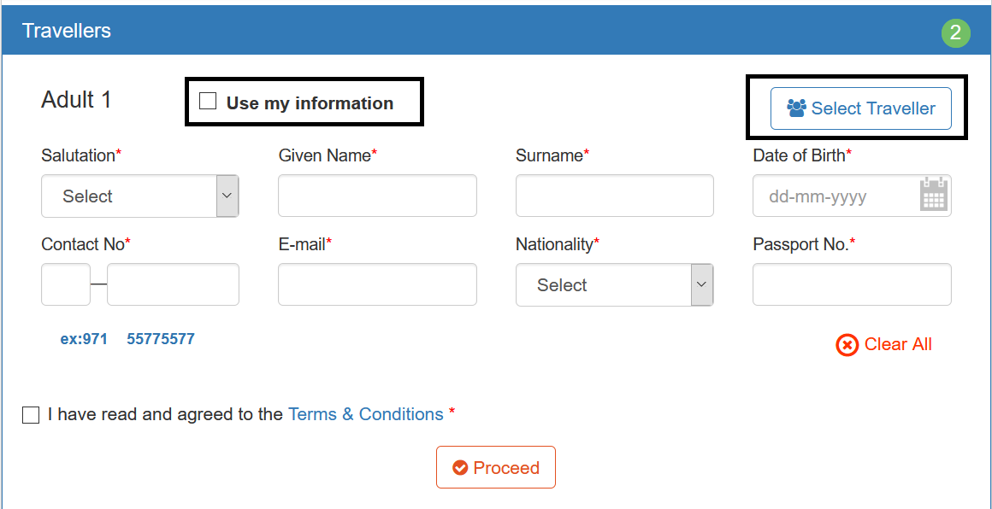
Fig: Guest Details Screen-1

Country code field:

- The country name and code (in brackets)
- Data should be populated when the user types the country name or country code and the field should be drop down list as well.
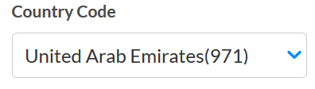

  - Guest User and Login from the Booking review screen:

    - If the user has come as a guest user, then in the Itinerary screen the user shall have two options (Continue as Guest or Login & Continue).
    - If the user has a B2C User ID login and password, then the User shall click the Login & Continue. The system shall redirect the user to the login screen, the user shall enter the Username and password and then will be redirected to the Itinerary screen as a logged in User.
    - The user shall be able to create a new guest or if the user wants to add his/her details then the user shall select the option “Use my profile”.
    - Or if the user wants to book for his/her dependencies then the user shall select from my traveller profiles. The system shall show the dependencies profiles and the user shall add the guest to the booking.
    - The user shall add the Guest details and checks the terms and conditions and the clicks the Proceed button to go to the payment gateway screen.

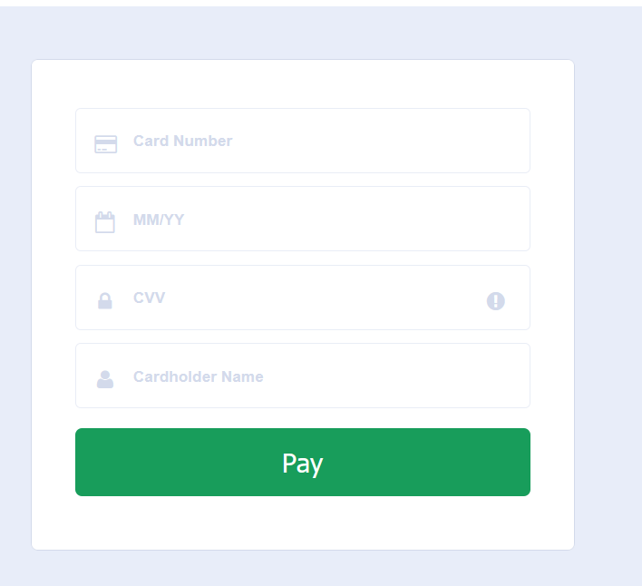
Fig 8: Payment Gateway screen

  - Payment And Booking Confirmation Process:
    - The user shall enter the credit card details and then clicks the pay button.
    - The user shall be redirected to the payment gateway system to block (pre-authorization) the payment.
    - Once the payment blocking (pre-authorization) is successful then the system shall send the booking confirmation request to the supplier.
    - Once the booking is confirmed from the supplier end, then the system shall send the authorization request (full settlement) to the payment gateway. Once the authorization request is successful, shall redirect to the booking confirmation page and also the voucher will be sent automatically to the user’s email ID. In the booking confirmation screen there will be an option for the user to send the voucher through email option.
    - If the payment is failed due to a payment related issues, then the system shall redirect the user to the booking review page with a relevant error message displayed to the user.
    - If the booking is failure due to an error response received from the supplier, then the system shall redirect the user to the booking review page with a relevant error message displayed to the user.

  - Booking Confirmation Page: In the booking confirmation page the following information shall be listed. Refer Sample Image Figure 9.
    - Booking confirmation Number
    - Status
    - Hotel Name
    - Check-in Date and Check-Out Date information
    - Room Details
    - Guest Details
    - Cancellation Policies of ART
    - Contact Details of ART
    - Option to send the email.

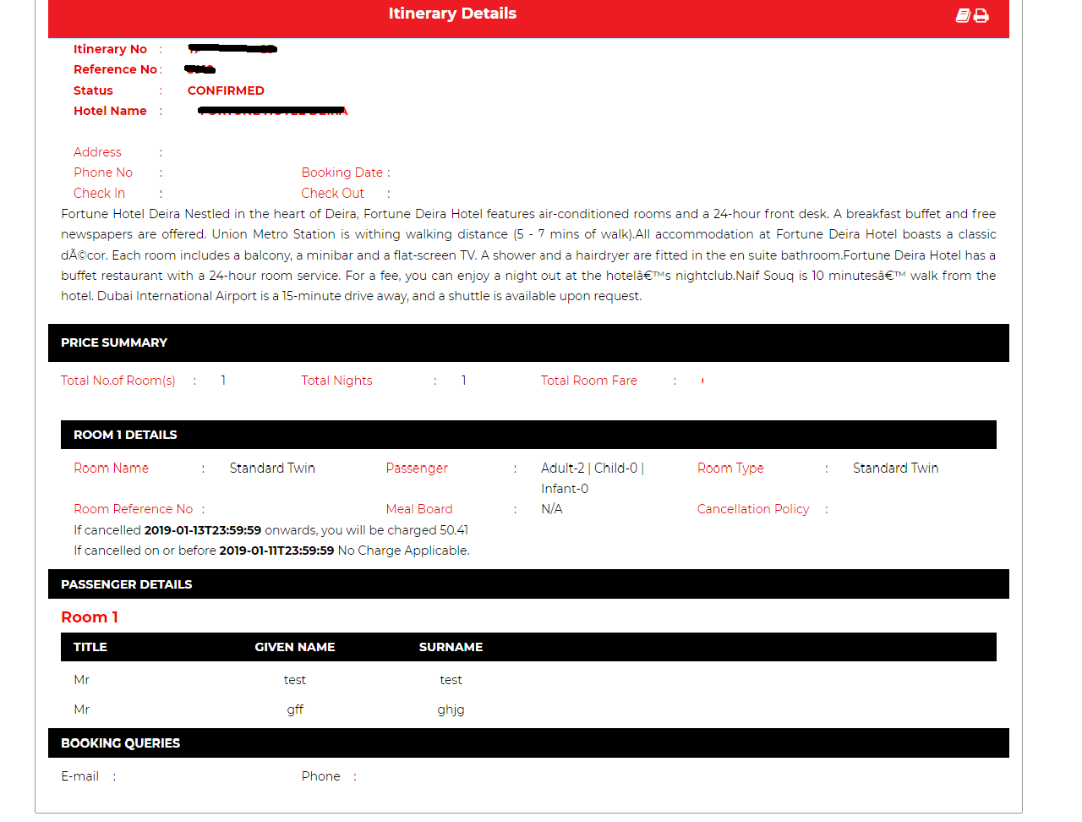
Fig 9: Hotel Booking Confirmation Page.

Booking Fulfilment Scenarios:

- Scenario 1: Hotel Booking (Success)
  - Action 1: User Redirected to the Itinerary Confirmation screen
  - Action 2: Itinerary Email Confirmation (with Voucher PDF) Sent to the Customer
  - Action 3: Itinerary Copy Email (with Voucher PDF) Sent to the Reservation Team
  - Action 4: Queue Mid office: The successful booking will be updated in the queue.
- Scenario 2: Hotel Booking (failed→Payment Failed- Payment Blocking Failure (No booking created, PG blocking failed)
  - Action 1: the system shall redirect the user to the booking review screen with the relevant error shown in the screen. The user can retry the payment again for 5 times. More than 5 times, system shall not allow the user for the payment and instead it show a message to call the call centre.
  - Action 2: Customer shall receive a payment failure email, stating the reason and try with payment methods.
  - Action 3: System should an email notification with the Passenger details (Name, Email ID, Contact number (Country code + Phone number), and itinerary to the call centre team or reservation team to take further actions to assist Passenger and make the sale happen The booking related information will be updated in the queue as On request booking.
  - Action 4: Queue Mid office: The booking related information will be updated in the queue as On request booking.
- Scenario 3: Hotel Booking (Failed→ PG Blocking successful but Booking failed)
  - Action 1: Redirected to the booking review screen showing the error that is related to the supplier.
  - Action 2: Customer shall receive an email on the payment success and about booking failure.
  - Action 3: System should an email notification with the Passenger details (Name, Email ID, Contact number (Country code + Phone number), City name, Hotel name, Room name and type, Check-in and Check-out dates, Country of Residence, Nationality, Total fare to the call centre team or reservation team to take further actions. Severity high.
  - Action 4: Queue Mid office: the support staff shall go check the NI portal and see if the amount is blocked or not. The staff then shall call the client to reconfirm the scenario and complete the booking either from B2B or from the supplier portal. Then the staff shall will authorize the payment from the NI portal. Update the status of the booking from the queue. then booking status shall also be changed under My booking for the customer. If the customer doesn’t want to confirm the booking or the support person is not able fulfil the booking, then the staff shall reverse the amount from NI portal that is blocked. The staff shall then update the status as cancelled from the Queue and immediately the system shall send an email to the customer stating that " The amount has been reversed to your account. For more details, please contact your bank".
- Scenario 4: Hotel Booking (Failed→ PG Blocking successful, booking successful, PG Auth failed.)
  - Action 1: Redirecting to a page where the system shall the system reference number and show the message as "Your seat has been blocked, Wait for the payment confirmation from the bank. We will get in touch with you as soon as possible".
  - Action 2: Customer shall receive an email on the seat blocking and the pending payment status.
  - Action 3: System should an email notification with the Passenger details (Name, Email ID, Contact number (Country code + Phone number), Hotel Booking reference number. City name, Hotel name, Room name and type, Check-in and Check-out dates, Country of Residence, Nationality, Total fare to the call centre team or reservation team to take further actions. Severity high.
  - Action 4: Queue Mid office: The support staff shall go check the NI portal and see if the amount is blocked or not. The staff then shall authorize the payment. The staff shall update the queue from pending to success. Once this is done, then the B2B system shall send the voucher copy through email to the client. And in my booking the status shall also be updated as success.

Approval

Prepared by | Signature | Date
Saivisweswaran
Convergent Technology Solutions
Approved by | Signature | Date

